**Build Solution**

What does this task do?

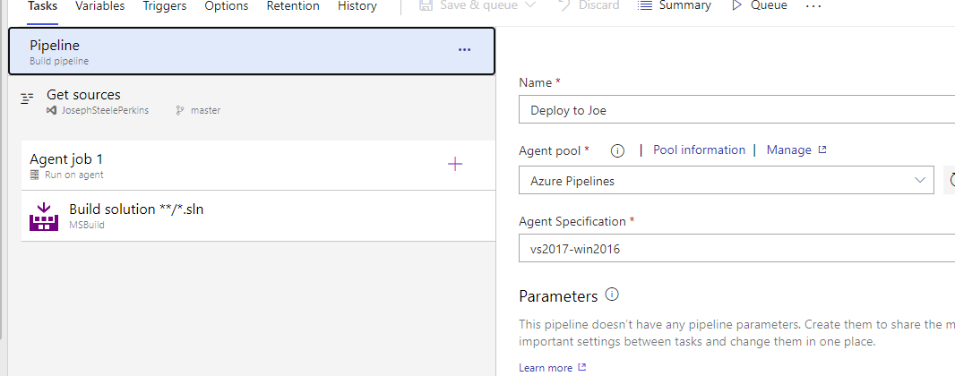

I would expect it to do the same as if I build a solution using Visual Studio. But that would create a dacpac. And if the task does that, where is it created? Can’t be in the repository. Anyway, lets prove that is doesn’t create a dacpac.

First, delete the dacpac

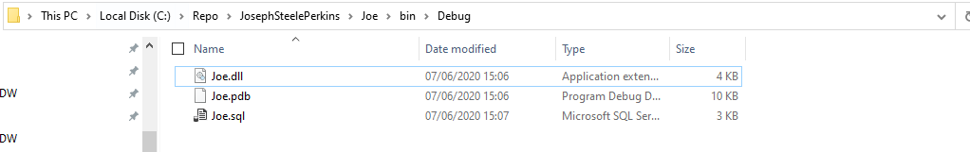

Now build the solution, and as expected, a dacpac is created.

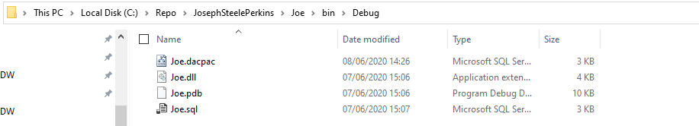

Okay, now remove the dacpac from the branch that the pipeline will run on.

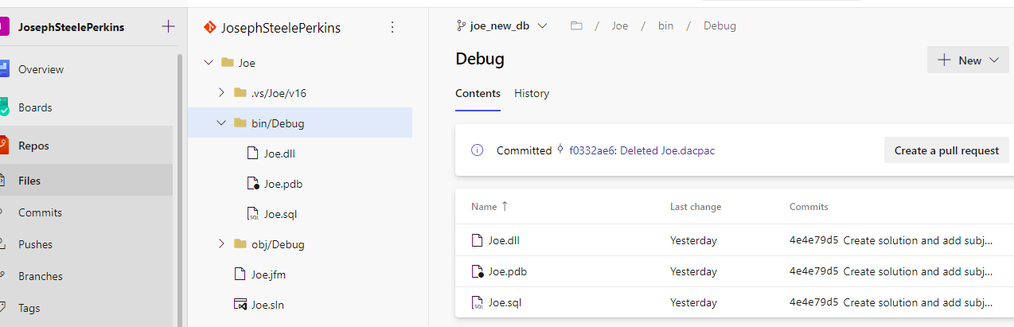

Now, run the pipeline.

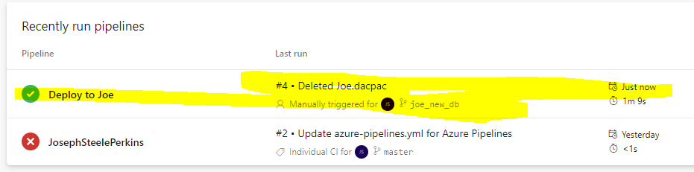

Success. But as expected, no dacpac on the branch

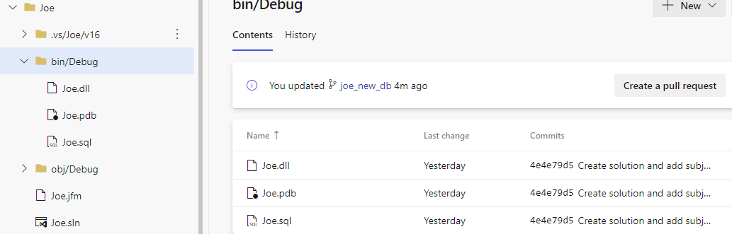

As an experiment, lets run the pipeline on the master branch which doesn’t have a solution.

As expected, it failed.

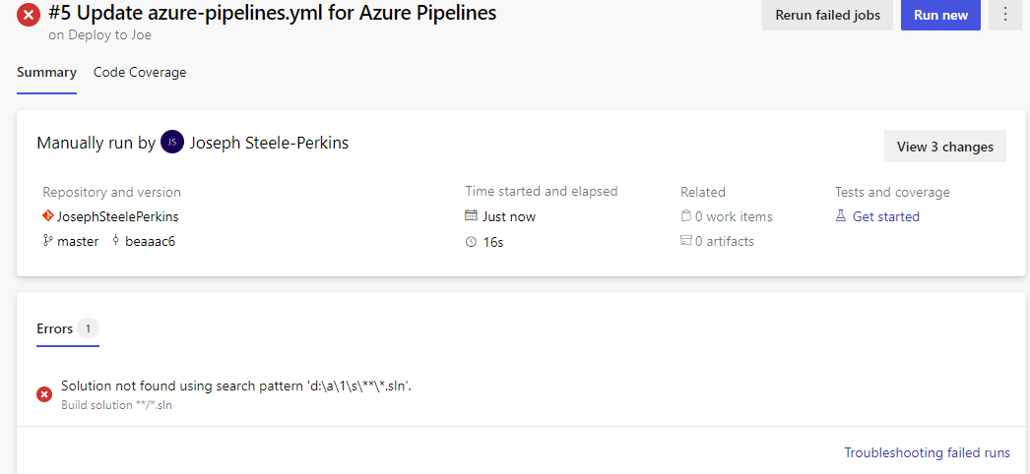

So where the hell is the DACPAC created?